VPC task -01
- Create VPC with 2 private and 2 public subnets. 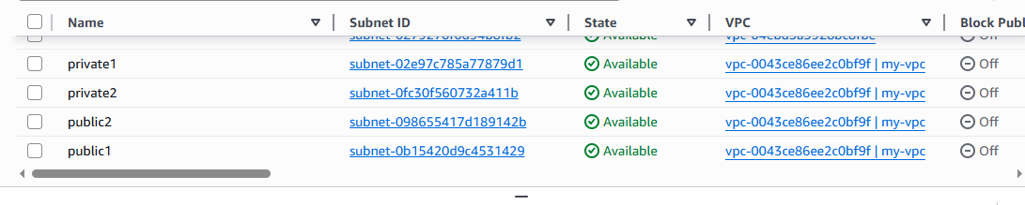
- Enable DNS Hostname in VPC.
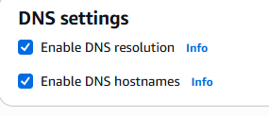
- Enable Auto Assign Public IP in 2 public subnets. 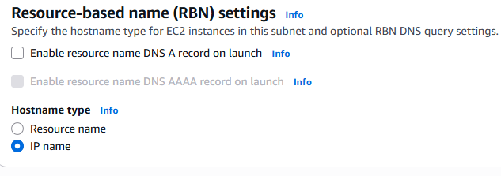
- Add 2 private subnets in private route table. 5.Add 2 public subnets in public route table. 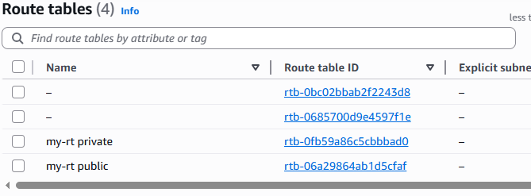

- Public route table will have the routes to internet and local. 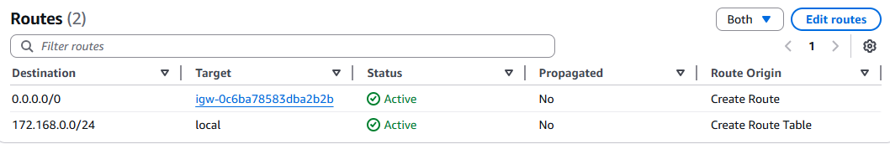
- Create EC2 in public subnet with t2.micro and install PHP. 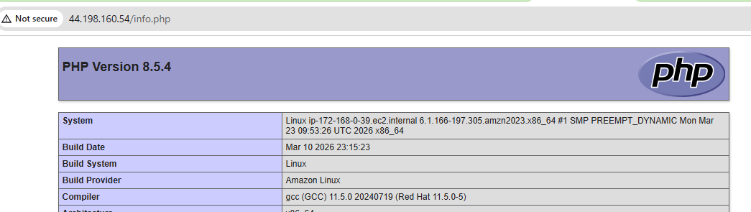
- Configure NAT gateway in public subnet and connect to private instance. 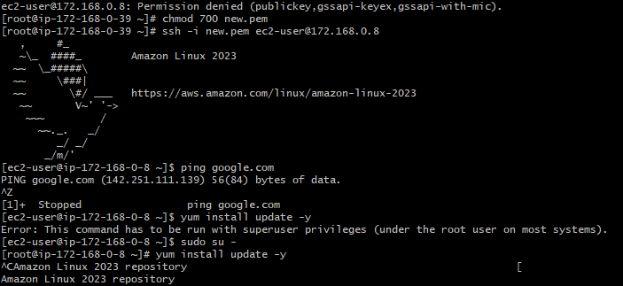
- Install Apache Tomcat in private EC2 and deploy a sample app. 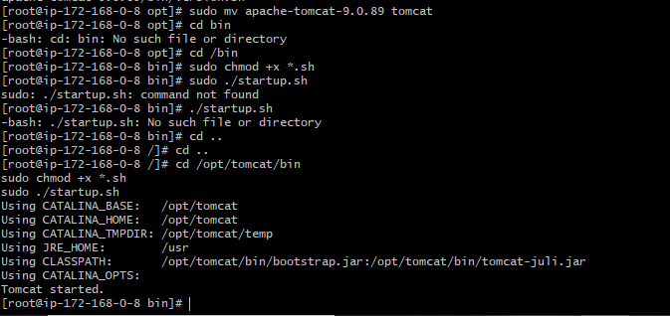 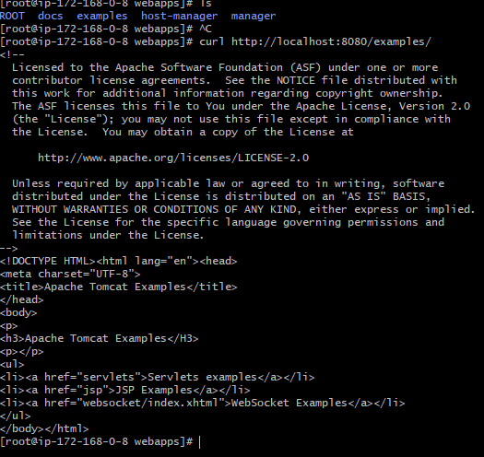
- Configure VPC flow logs and store the logs in S3 and CloudWatch. 